2023-2024
CANNON BEACH ACADEMY
COMMUNICABLE DISEASE PLAN

This document was made in collaboration with Clatsop County Public Health Authority, Clatsop County school district registered nurses, Oregon Department of Education and The Oregon Health Authority. (Created: 07-2020: Last Update: 09/15/2023)

Communicable disease control and prevention is of significant importance in creating a safe and healthy school environment for students and staff.

A communicable disease is an infectious disease that is transmissible by:
- contact with infected individuals or their bodily discharges or fluids,
- contact with contaminated surfaces or objects,
- ingestion of contaminated food or water,
- direct or indirect contact with disease vectors/carriers.

Although the terms communicable disease and contagious disease are often used interchangeably, it is important to note that not all communicable diseases that are spread by contact with disease vectors/carriers are considered to be "contagious" diseases since they cannot be spread from direct contact with another person (ACPHD, 2013).
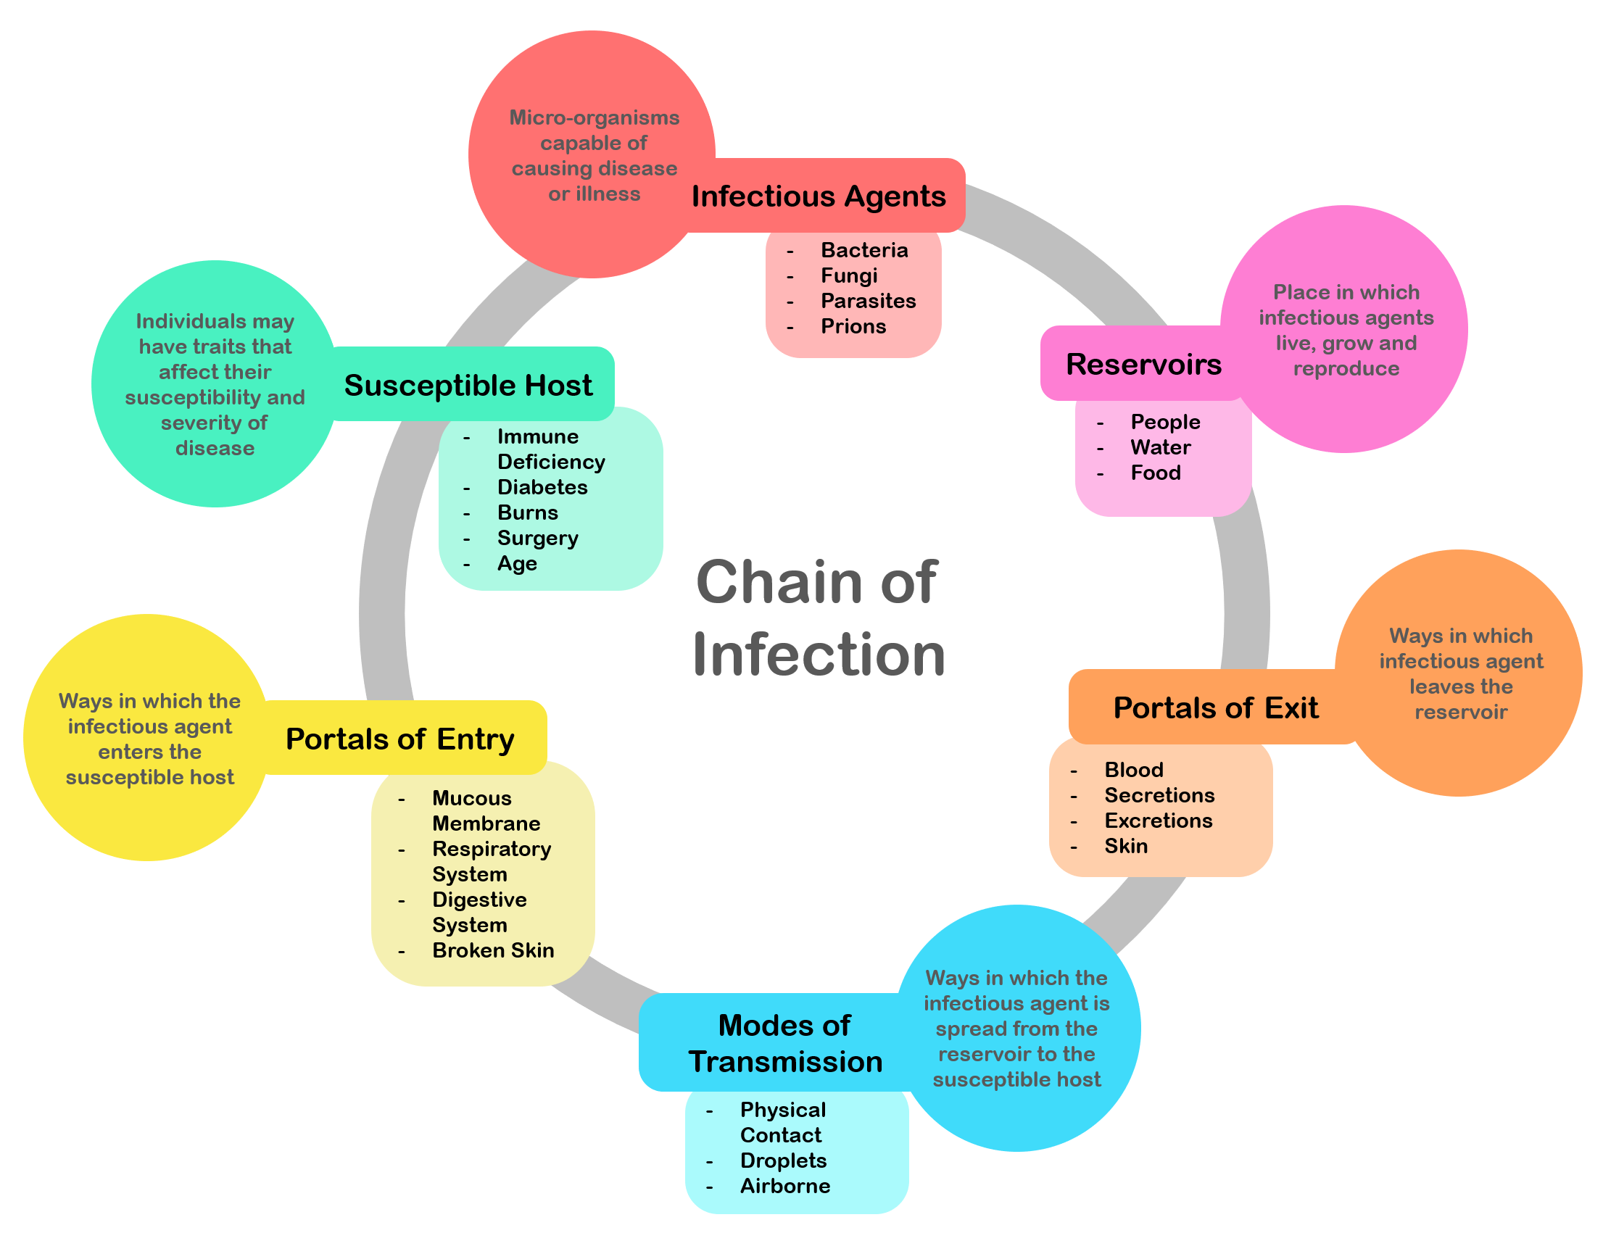

In the school setting there is a prevention-oriented approach for communicable disease which is grounded in education, role modeling and standard precautions and hygiene. However, the nature of a population-based setting lends to the need to establish practices for measures and interventions associated with exposures or potential exposure. This document focuses on a population based set of practices for communicable disease prevention. The subsequent Exposure Control Plan discusses work practice control measures for staff.

CBA Communicable Disease-Related Board Policies
Communicable Diseases-Student JHCC
Communicable Diseases-Student JHCC-AR
Communicable Diseases-Staff GBEB
Communicable Diseases-Staff GBE-AR
Student Health Services JHC
Animals in District Facilities ING
Animals in District Facilities IN-AR

Oregon Legislation/Administrative Rules Regarding Communicable Disease

OAR 333-019-0010
Disease Related School, Child Care, and Worksite Restrictions: Imposition of Restrictions

OAR 581-022-2200
Health Services

OAR 410-133-0000
School-Based Health Services

Oregon Health Authority & Oregon Department of Education

Oregon Communicable Disease Guidelines for Schools

Communicable Disease Prevention
There are a multitude of methods that can be applied to control communicable diseases at a variety of levels. Some of the most common include vector control, hygiene, sanitation and immunization. Fully endorsing the control and prevention of communicable diseases requires a level of understanding of how communicable diseases can be spread. How these communicable diseases are spread depends on the specific infectious agent. Common ways in which communicable diseases spread are include:
- Physical contact with an infected person, such as through touch (staphylococcus), sexual intercourse (gonorrhea, HIV), fecal/oral transmission (hepatitis A), or droplets (influenza, TB)
- Contact with a contaminated surface or object (Norovirus), food (salmonella, E. coli), blood (HIV, hepatitis B, hepatitis C), or water (cholera, listeria);
- Bites from insects or animals capable of transmitting the disease (mosquito: malaria and yellow fever; flea: plague); and
- Travel through the air, such as measles.
In the school setting the most frequent risks are associated with direct contact with ill individuals or contamination of surfaces or through airborne transmission. Primary sources of prevention include hand and surface hygiene, isolation, exclusion and standard precautions.
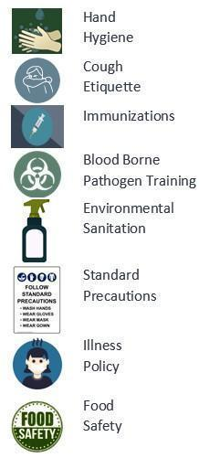
This section of the plan will provide a brief overview
- Common Childhood Infectious Disease
- Vaccines
- Respiratory/Cough Etiquette

Common Childhood Infectious Disease
There are a variety of Common Childhood Infectious Diseases that are regularly encountered in the school setting. Routine childhood respiratory illnesses such as the common cold (adenoviruses, coronaviruses, rhinoviruses) or conditions such as bronchitis, sinusitis, and tonsillitis caused by a variety of bacteria and viruses occur throughout the year. Other conditions such as gastroenteritis (norovirus most frequently) and croup (most commonly parainfluenza) and influenza (A & B) most often occur seasonally. Other common conditions include strep throat, hand foot and mouth disease, fifths disease and staph skin infections. Other, more severe infectious diseases occur sporadically throughout the district throughout the school year.

Vaccines
In the school setting vaccines are an important piece of communicable disease control. Vaccines are a requirement for attending school in Oregon. However, it is important to remark that certain populations may not be vaccinated because of medical contraindications or because of religious or philosophical decisions. Each school has a record of which students are and are not vaccinated with routine childhood immunizations as a primary control measure for outbreaks of vaccine preventable diseases.
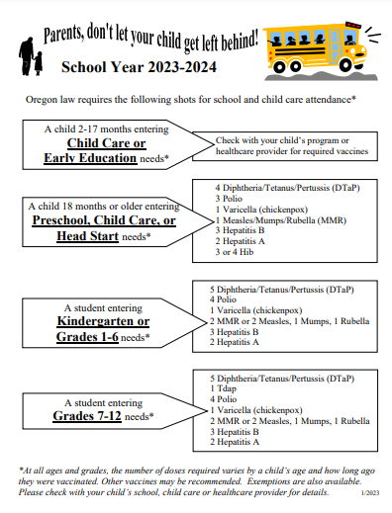

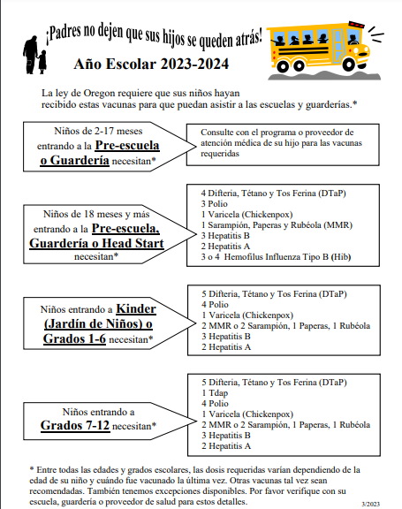
You can find a list of the immunizations required by age by the state of Oregon on the Oregon Health Authority website at:

https://www.oregon.gov/oha/PH/PREVENTIONWELLNESS/VACCINESIMMUNIZATION/GETTINGIMMUNIZED/Pages/SchRequiredImm.as

Hygiene
Prevention oriented measures are grounded in education of how diseases are transmitted and practice application related to appropriate sanitizing measures and precautions. Hygiene and sanitation are some of the most important methods of disease prevention.
Handwashing is one of the single most important methods of keeping germs at bay, specifically in the school setting. Appropriate handwashing practices should be taught, role modeled and practiced. As additional preventative measures.
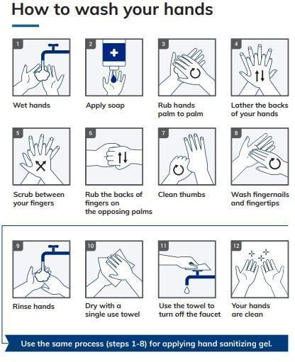

(Image: Multicare.org)

Additional hand hygiene information can be found on the Center For Disease Control website at: www.cdc.gov/handwashing/index.html

Hand sanitizer, while not effective against a large number of pathogens, should be made available for times that handwashing is not immediately accessible. Hand sanitizer should be easily accessible throughout the building, specifically in high contact areas and at entrances and exits as feasible. Hand sanitizer should be accessible in each classroom.

Students and staff should wash hands when:
Before, during, and after preparing food
Before eating food
Before and after caring for someone at home who is sick with vomiting or diarrhea
Before and after treating a cut or wound
After using the toilet
After changing diapers or cleaning up a child who has used the toilet
After blowing your nose, coughing, or sneezing
After touching an animal, animal feed, or animal waste
After handling pet food or pet treats
After touching garbage (CDC, 2020)
When immunocompromised students and staff are present increase in hand hygiene frequency is a necessary prevention intervention.

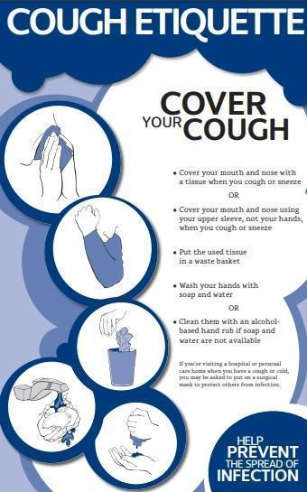
Respiratory Hygiene/Cough Etiquette
Respiratory hygiene and cough etiquette are terms used to describe infection prevention measures to decrease the transmission of respiratory illness (e.g., influenza and cold viruses). A respiratory infection is spread when a person who is infected with a virus coughs or sneezes. The droplets released from an ill person’s cough or sneeze can travel for several feet reaching the nose or mouth of others and causing illness. Viruses can spread easily from person to person through direct contact via touching or shaking hands. Droplets can also live for a short time on a variety of objects such as high touch areas like door knobs or desks.
Because some individuals cough without having respiratory infections (e.g., persons with chronic obstructive lung disease), we do not always know who is infectious and who is not. Therefore, respiratory hygiene and cough etiquette are very important components to protecting yourself from illness and preventing others from becoming ill. Like hand hygiene, respiratory hygiene is part of the standard precautions that should be taught, practiced
(Image: Manitoba Department of Health)

and role modeled to prevent the spread of disease.

Environmental Surface Cleaning
Clean schools contribute to healthy environments and minimize the risk of communicable disease transmission. Some of the important concepts associated with reduction in illness include scheduling routine cleaning of each classroom and common areas, ensuring appropriate stock of appropriate sanitizers and disinfectants, ensuring garbage is emptied regularly and ensuring any classrooms with pets have a cleaning plan in place to minimize odors or contamination. While environmental cleaning is largely governed by facilities management and custodial services, there are certain classroom measures that can be practiced to improve cleanliness and reduce the risk of illness transmission during peak illness such as increasing access to sanitizing wipes, tissue and hand sanitizer.

Communicable Disease Exclusion
Communicable diseases are transmitted from person to person by various routes. While some conditions are restrictable based on diagnosis, more often early identification of signs and symptoms of communicable disease is of paramount importance to increase the health of the school population and decrease school absenteeism. In the school environment, many communicable diseases are easily transmitted from one individual to another. Effective control measures include education, avoidance of risk factors, sanitation, vaccination, early recognition of symptoms, health assessment, prompt diagnosis and adequate isolation or treatment (ODE, 2020).
Oregon public health law mandates that persons who work in or attend school who are diagnosed with certain diseases or conditions be excluded from school until no longer contagious. However, diagnosis often presumes a physician visit and specific testing, and schools must often make decisions regarding exclusion based on non-diagnostic but readily identifiable signs or symptoms. Please DO NOT SEND AN ILL STUDENT TO SCHOOL. If your student is ill please CONTACT THE SCHOOL. Please contact your health care provider about any SERIOUS ILLNESS or if you are worried about your students health. If you need help in finding a healthcare provider, you may contact the local public health authority at 503-325-8500. Examples of restrictable signs or symptoms are listed in Appendix B.

Restrictable Diseases
Restrictable diseases are specific infectious disease diagnoses that require students or staff to remain at home for a specified amount of time to limit transmission. Restriction is typically associated with the communicability or severity of a disease. Restrictable diseases are reportable to the local health department (LPHA). The local health department typically notifies school health services. Although, there are occasions when the parent will notify the school first.
Students with diagnoses of disease restrictable by the local public health authority (LPHA) under Oregon Administrative Rule (OAR) 333-019-0010 should return to school when documentation is obtained from the local health department (LPHA) indicating they are no longer communicable including:
- Diphtheria,
- Measles,
- Salmonella
- Typhi infection,
- Shigellosis,
- Shiga-toxigenic Escherichia coli (STEC) infection,
- Hepatitis A,
- Tuberculosis,
- Pertussis,
- Rubella
- Acute Hepatitis B.

If a report is made to the school office, administration or other school staff in regards to any suspected communicable disease diagnosis in students or staff, this should immediately be referred to the district RN. This should be regarded as an urgent referral to the RN if the suspected disease is regarded as a restrictable condition. The district RN and administrators will identify the need for communication, surveillance or control measures. The interventions and communications are driven by multiple factors including the diagnosis, student health status, risk of exposure, number of individuals infected and risk to cohort or specific students. School staff receiving reports should not inform any other students, staff or parents of the report.

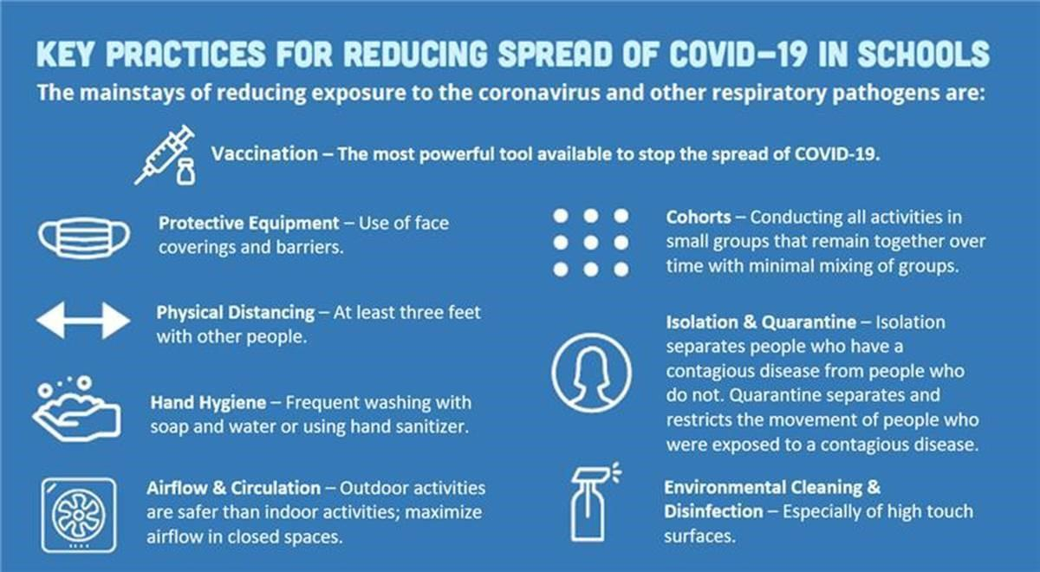

OHA/ODE Communicable Disease Guidelines are linked below:
Oregon School Communicable Disease Guidelines

Isolation Spaces
As per OAR 581-022-2220, the school district is required to maintain a prevention oriented program which includes a health care space that is appropriately supervised, adequately equipped for first aid, and isolation of ill or injured child/children from the student body. When students are identified with restrictable diseases or excludable symptoms, students should be isolated in an appropriate space until they can be dismissed to home. It is best infection control practice to separate potentially infectious/contagious students/cohorts from the healthy student population in a separate isolation room. Additionally, each bus and grade school classroom will have an isolation area in which symptomatic students may isolate temporarily before accessing the isolation room on campus.

Vaccine Preventable Disease
A vaccine-preventable disease (VPD) is an infectious disease for which an effective preventive vaccine exists. Current VPD routinely immunized for in the United States includes:
- Diphtheria*
- Tetanus*
- Measles*
- Mumps*
- Rubella*
- Haemophilus influenzae type b infections (Hib)*
- Pneumococcal infections*
- Meningococcal disease*
- Pertussis (whooping cough) *
- Poliomyelitis (polio)*
- Hepatitis A*
- Hepatitis B*
- Varicella
- Influenza
*Most VPD’s are also notifiable diseases, meaning they are reportable to the local health department and are under constant surveillance. Other diseases where a risk may arise for a particular person or group of people in specific situations are also notifiable conditions, but are not routinely immunized for in the US.

Gastroenteritis
An outbreak of gastroenteritis is defined as more cases than expected for a given population and time period. For example, two children in a 25-person classroom with vomiting or diarrhea within one week could potentially indicate an outbreak. Because the nature of norovirus (viral gastroenteritis) is common, seasonal and highly infectious, it is unlikely to result in an outbreak investigation unless the number infected, frequency or duration is unusual. Because symptoms of bacterial gastroenteritis may start with a similar presentation, it is important to evaluate the severity for the duration of illness.
Indicators to report to the district RN include:
  - Multiple children with compatible symptoms in 48 hours within the same cohort, but separate households.
  - More than 2 cases of diarrhea with bloody stool in the school setting.
  - Sudden onset of vomiting in multiple persons in the same cohort.
  - Any unusual combination of gastrointestinal symptoms, severity, duration or incidence.

Other Circumstances
Less commonly, outbreaks of skin infections, novel diseases, or unusual infectious disease circumstances arise. In efforts to ensure appropriate disease control, interventions and follow up will occur. These situations should be deferred to the school nurse immediately and will be handled on a case by case basis. Examples of these circumstance may include:
  - More than 2 students from separate households with reported compatible skin infections in the same school setting or athletic team.
  - Any student or staff member coming into contact with blood, saliva or feces from a non- domestic animal.
  - Any student or staff coming into contact with blood that is not their own.
  - Any combination of illness, symptoms, severity, duration or frequency that seems unusual as compared to routine seasonal illness.
The school nurse may decide that additional control measures or data collection is necessary and will consult with administration and LPHA as needed, in regards to determined outbreaks or novel diagnoses. The school RN should always be consulted regarding any written communication that may be developed to notify parents about illness, disease outbreaks, and risks to students, families, and staff and/or control measures specific to the outbreak. For more information, please refer to the district’s Pandemic Response Plan.
Any presentation of illness or combination of illnesses as described above should be reported to the district RN and administrator.

During the School Year, the following handwashing, respiratory etiquette practices, and surface cleaning measures are required by the Warrenton Hammond School District as recommended by the Oregon Department of Education and OHA:
- All people on campus should be advised and encouraged to wash their hands frequently.
- Hand sanitizer dispensers will be available near all entry doors and other high-traffic areas.
- All staff, students, and visitors will wash with soap and water for 20 seconds or use an alcohol-based sanitizer when entering/exiting school each day.
- Students should be directed to wash their hands before and after use of playground equipment.
- Students should be directed to wash their hands before meals and will be encouraged to do so after.
- Students will be reminded throughout the day through signage and verbal reminders from staff to wash hands and use cough etiquette.
- Schools will work to clean, sanitize, and disinfect frequently touched surfaces between uses and maintain clean and disinfected environments including classrooms, cafeteria settings, restrooms and playgrounds.

Animals in School
Animals in schools can have a positive effect in the school environment, but also may cause infectious disease issues for staff and students. School board policies and district applications should be visited for this. Other considerations should be made in regard to controlling spread on infectious disease from animals:
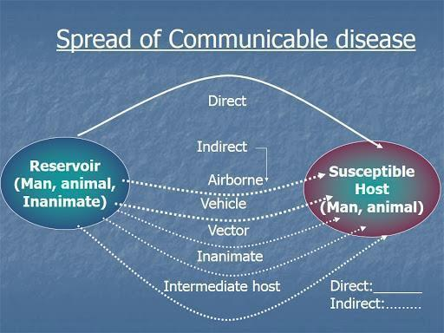
  - Wild mammals, alive or recently dead, should not be allowed in school. Bats and skunks have a significant risk of being rabid, and other wild animals may be more prone to causing injury through bites and scratches.
  - Dogs, cats, and ferrets allowed in school are recommended to have met current vaccine requirements.
  - Any animal bites on school premises should be reported to the local health department for follow up.
  - Animals who are ill should not be allowed into the school setting.
  - Class pets should be removed if they become ill.
  - Handwashing must occur before and after handling of animals to prevent diseases such as transmission.
  - Animals should not be present or handled in areas where food and drink are consumed or prepared.
  - Children should not kiss high risk animals such as chicks, ducks, turtles, and other reptiles.
  - Children should always be monitored with animal interactions.
  - Consider the medical needs of students who may be immunosuppressed or who may have allergies as they may become severely ill when exposed to certain pathogens.
  - In the event that a student in a classroom is diagnosed with a disease known to be carried by animals (e.g. campylobacteriosis or salmonellosis) the animal should be removed from the classroom setting until the risk is determined to be resolved.

Food Safety
Food safety for kitchen staff is supervised by nutrition services. For the purpose of population based health and food preparation and consumption within the classroom, general food safety standards and disease prevention principles should be endorsed.

For all classrooms
  - Hand hygiene is practiced prior to eating,
  - General principles of food safety can be taught that are age appropriate.
  - Food sharing should be avoided
  - For classroom and school sponsored events, only commercially prepared products are permitted. No homemade goods from non- licensed kitchens.

For all culinary classrooms
  - Hand hygiene should always be encouraged
  - Age appropriate food safety principles are taught.
  - Appropriate food handling processes must be taught, role modeled and endorsed. This includes overview of:
    - Hand hygiene and appropriate use of gloves.
    - Clean surfaces and appropriate use of sanitizers.
    - Separating raw and ready to eat foods/ avoidance of cross contamination.
    - Cooking food to appropriate temperatures.
    - Appropriate storage and refrigeration.
    - Measures to prevent allergic reactions.
    - Abstaining from food preparation when specific symptoms or specific illnesses have been identified.
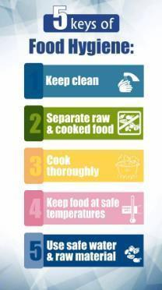

References
Alameda County Public Health Department (2013) Communicable Disease. Retrieved from http://www.acphd.org/communicable-disease.aspx
BC Center for Disease Control (BCDC) (2009) A quick Guide to Common Childhood Diseases. Retrieved from http://www.bccdc.ca/resourcegallery/Documents/Guidelines%20and%20Forms/Guidelines%20an
%20Manuals/Epid/Other/Epid_GF_childhood_quickguide_may_09.pdf Centers for Disease Control and Prevention. (2020). Influenza. Retrieved from
https://www.cdc.gov/flu/about/index.html
CDC (2020) When and how to wash your hands. Retrieved https://www.cdc.gov/handwashing/whenhow handwashing.html
Minnesota Department of Health (2020). Teaching Hand Hygiene. Retrieved from https://www.health.state.mn.us/people/handhygiene/curricula/index.html
Montana Department of Public Health and Human Services (MDPHHS) (2018) Communicable Disease: A guide for Schools in Montana. Retrieved from https://dphhs.mt.gov/Portals/85/publichealth/documents/CDEpi/CDGuideforSchools2018_Final.pdf
Oregon Department of Education (2020) Communicable Disease Guidance for Schools. Retrieved from Oregon Department of Education Communicable Disease Guidance Document.
Virginia Department of Health (2011) FAQ Respiratory Hygiene and Cough Etiquette. Retrieved from https://www.vdh.virginia.gov/content/uploads/sites/3/2016/01/RespiratoryHygieneCoughEtiquett
_FAQ.pdf
Weatherspoon, D. (2019) Acute Viral Respiratory Infections. Retrieved from https://www.healthline.com/health/acute-respiratory-disease
Images:
  - CDC.gov
  - Manitoba Department of Health
  - Multicare.org
  - Open University
Appendix A: Personal Protective Equipment (PPE)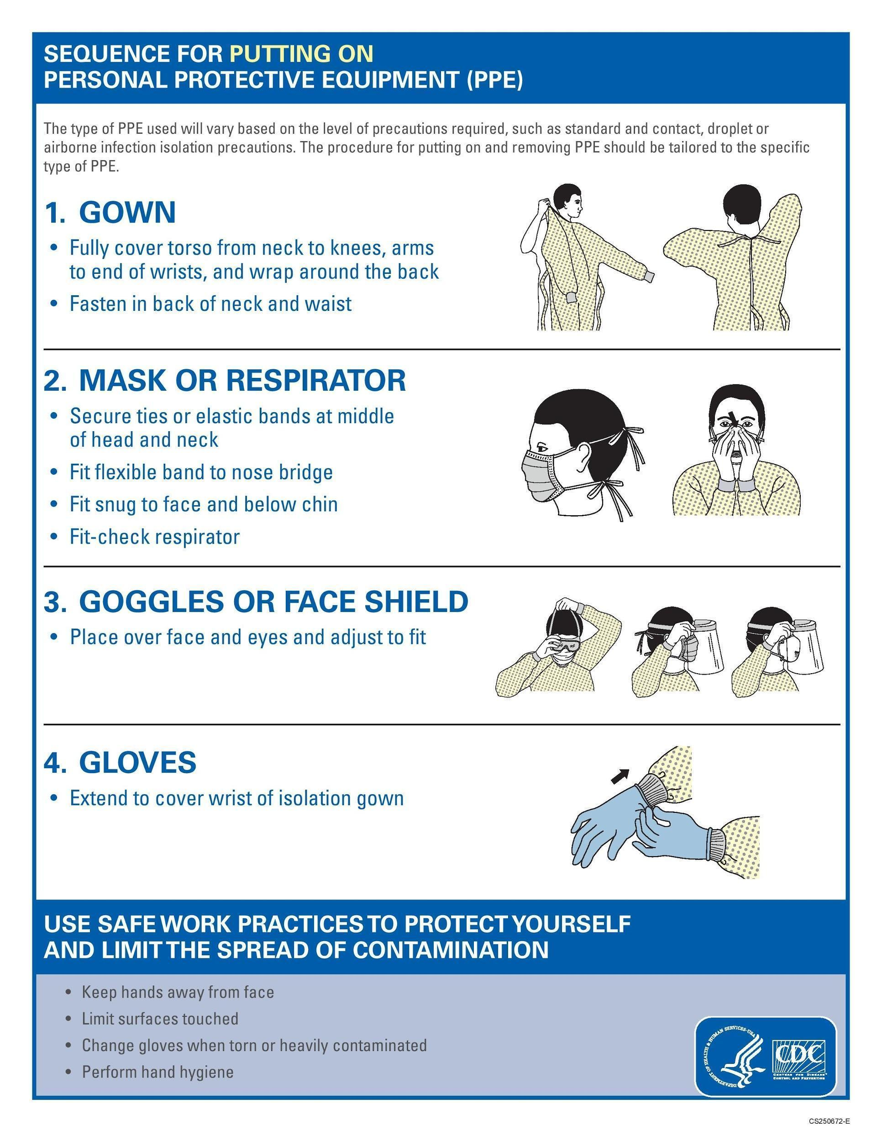
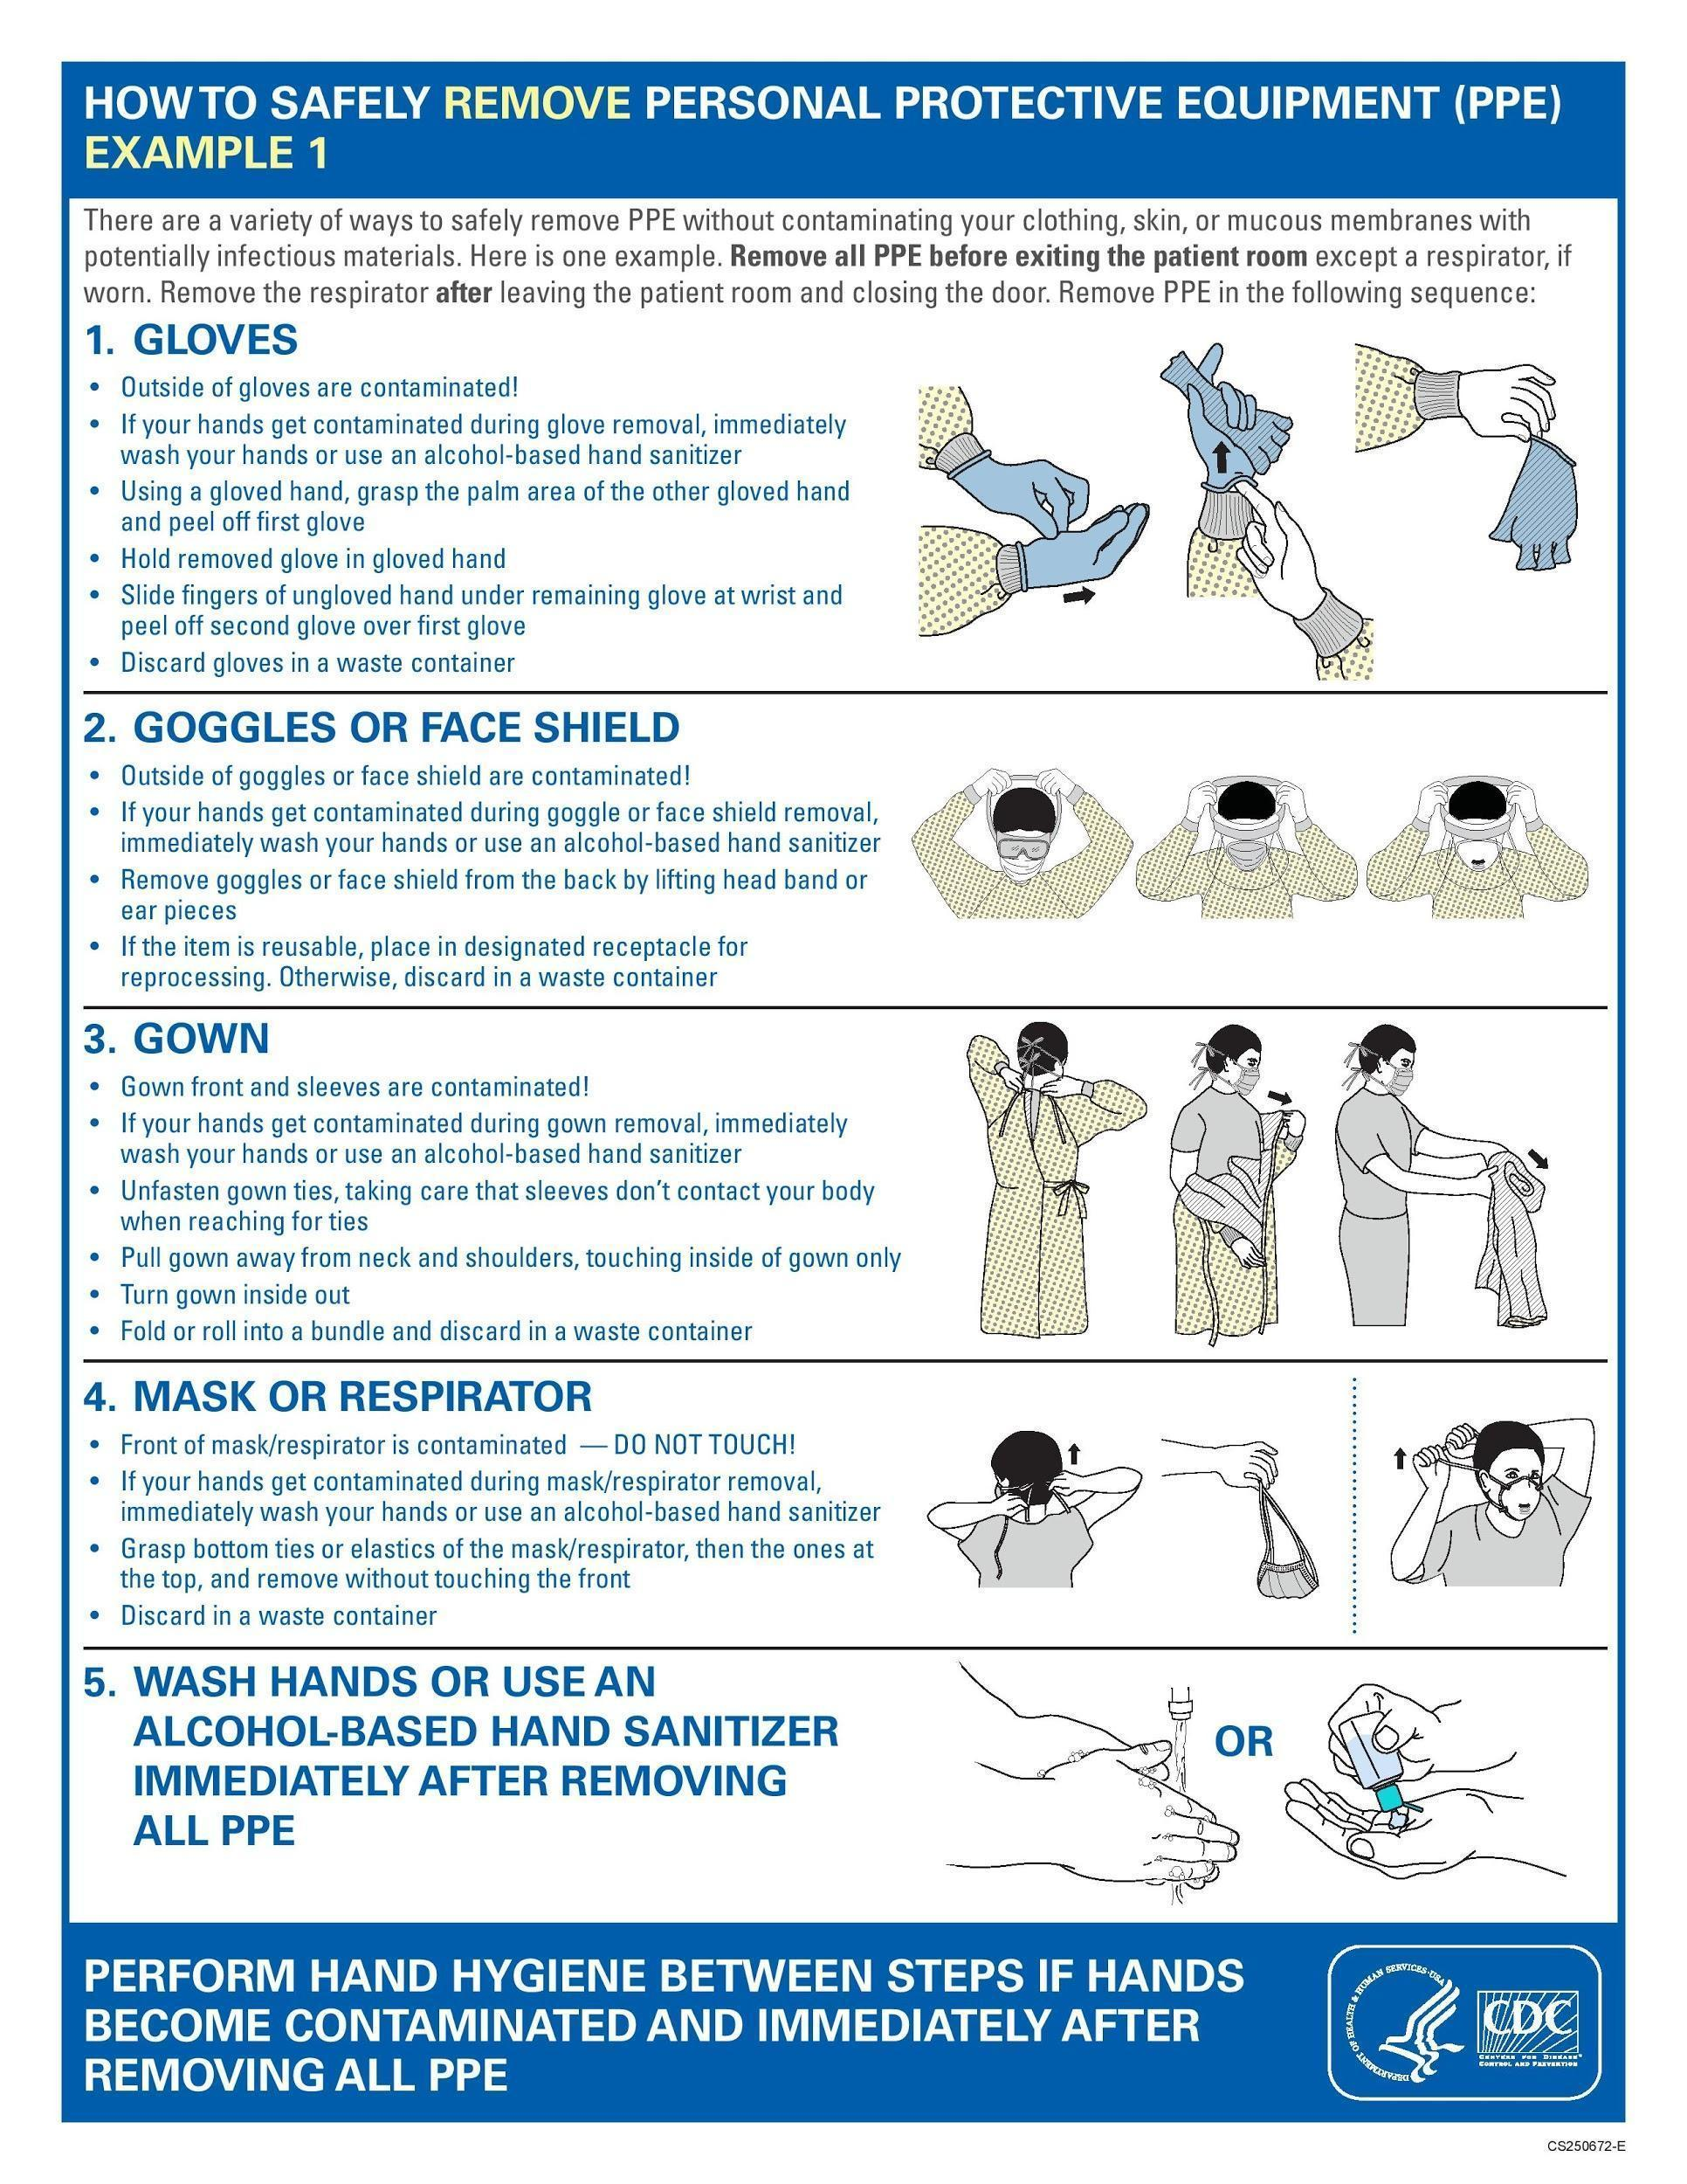
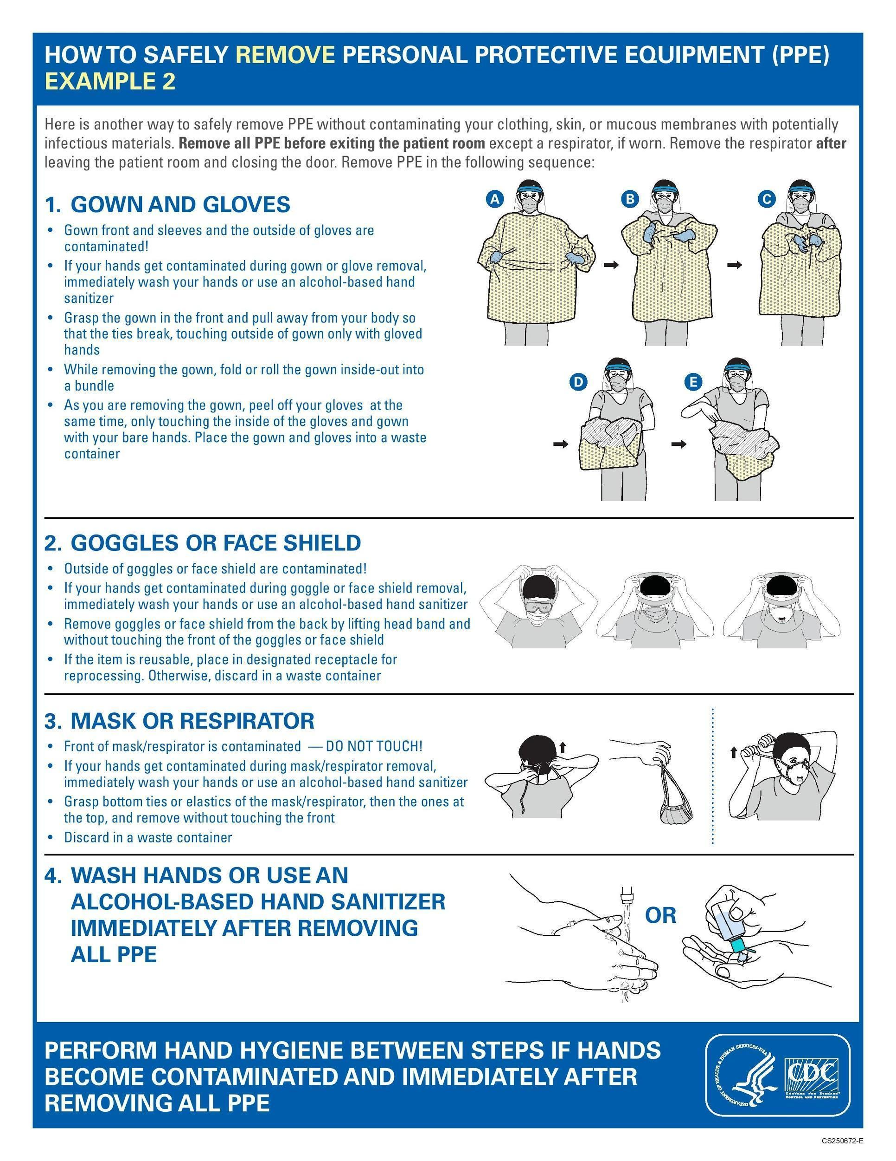

Appendix B: YOUR CHILD SHOULD STAY HOME WHEN (Page 13)
Oregon Health Authority Communicable Disease Guidance 08/2022 guideline for exclusion and Local Public Health Authority (LPHA) (Clatsop County Health) Health Care Provider (HCP). This chart of concerns does not mention every possible complaint indicating exclusion. Does not replace Medical Provider advice.(May refer to Pandemic/COVID-19 specifics)

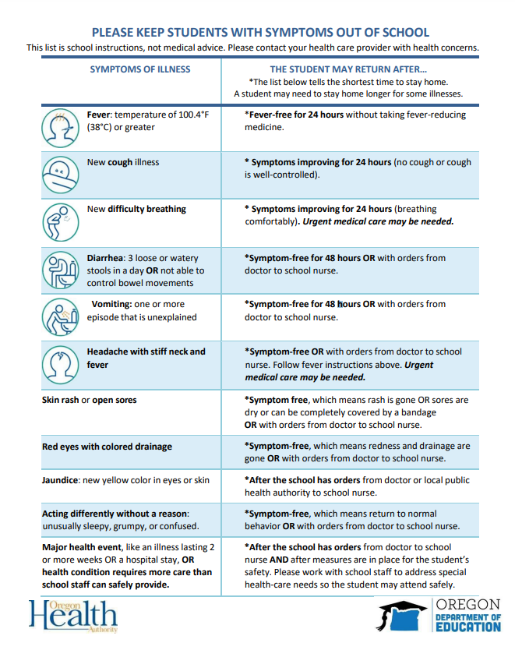

A variety of other conditions may not be excludable; however personal physicians may restrict a student from returning to school for a specific duration. In this case a provider’s note is needed.

